A notice to churches
Please send your notices for sharing with Horsham Churches Together to admin@horshamct.org.uk by Wednesday 3pm, as notices are usually published from approximately 4pm each Wednesday. Any notices received after this publication time will be held for the following week.
Please read the HCT privacy notice for details on how we collect, store and process your personal information under UK GDPR. The HCT administrator Anna Pisani can be contacted during office hours on Wednesdays.

Check out the new Horsham Churches Together website, including the Community Pages section,

Horsham Churches Together Notices
12th November 2025

Contents
- News
- Christmas Launch Party
- TeachBeyond are offering, free of charge, a range of Biblical resources (books)
- A plea for good condition tents, sleeping bags and roll mats/gym mats
- Lifespring Explorers
- Christmas Appeals
- Salvation Army, Christmas Appeal: ‘Be a star and donate a gift’
- Horsham Matters’ Christmas Appeal
- Events
- Sunday 16th November, 6pm, ‘One New Man’ @ Kingdom Faith
- Thursday 20th November – Evening Chamber Music Concert at Holy Trinity Church
- 19th, 29th November & 10th December: Events @ Dalesdown
- Saturday 22nd November: Horsham Salvation Army’s Christmas Fayre
- Saturday 22nd November: Horsham Matters Community Packing Day
- Sunday 23rd November: HCT Worship & Prayer Evening
- Saturday 29th November 2025, Horsham Fairtrade Christmas Market and the Sussex Green Hub
- Saturday 29th November, Wreath Making Workshop
- Saturday 29th November: Billingshurst Choral Society will be playing @ St Mary’s Church Horsham
- Sunday 30 November 2025 – Kingdom Faith Vision Event
- Friday 5th December: ‘The Magic of Christmas’
- Saturday 6th December: Carols in the Carfax 2025
- Saturday 13th December: Trafalgar Community Choir ‘A Christmas Pudding Time'
- Saturday 10th of January 2026: The Way of the Spirit - Word & Spirit - LIFE!
- Save The Date
- Advanced notice of HCT Events and Forums
- Prayer of the week
- Peace in the Rush
- Employment Opportunities
- Horsham Matters are hiring! - Part-Time Communications & Marketing Officer
- Frontline Administrator required at Horsham Matters
- Vacancy at Horsham Matters: Retail Assistant – 20 hours per week

- Volunteering Opportunities
- Governor vacancies at All Saints CE Primary School
- Horsham Matters need Volunteers
- Volunteers needed at Dalesdown
- YMCA Horsham Y Centre are looking for volunteer Chaplains
- Volunteer Trustees required at The Oasis

- News

- Christmas Launch Party
Horsham town centre will be alive with festive music and entertainment from 4pm til 9pm on Friday 21st November for Horsham's Christmas Launch Party and a performance from the Trinity Church Players at 7:30 to 8.30pm in Piries Place.

There will also be late night shopping 4-8pm, including at Horsham Matters' Love It Again shop.

For further information visit Horsham District Council's website

Sadly, the 'Carol Singing Lantern Parade' through Horsham town centre won't be happening this year, but everyone is invited to join us at 11:30am on Saturday 6th December for Carols in the Carfax, with music from the Slinfold Concert Band and a talk by Rev Tim Stilwell.
Back to Contents

- TeachBeyond are offering, free of charge, a range of Biblical resources (books)
TeachBeyond, a Christian mission organisation, is downsizing its global office in Horsham and, due to reduced storage space, would like to offer free of charge a range of Biblical resources (Bible commentaries, Biblical exposition, books on Christian living). Download the book list, 3 pages including photos, here. If interested in picking up one or more of the resources at Richmond House, 13 Carfax RH12 1AQ (junction with Medwin Walk, near Swan Walk entrance), please contact cphillips@teachbeyond.org (Clive Phillips).

Back to Contents

- A plea for good condition tents, sleeping bags and roll mats/gym mats
Turning Tides Outreach need small good condition tents, sleeping bags and roll mats/gym mats. If you are able to assist please email Sian jones.898@btinternet.com

Back to Contents

- Lifespring Explorers
Lifespring Church are launching a new stay & play group for 0-4's and their grown-ups, called ‘Lifespring Explorers’ from Thursday 13th November, download a flyer with more information.
Back to Contents

- Christmas Appeals

- Salvation Army, Christmas Appeal: ‘Be a star and donate a gift’
Christmas is fast approaching, and preparations are beginning again at The Salvation Army in Horsham, to offer help to families who are experiencing difficulties, with referrals made through Schools and Social Services. Support from other churches and the general public, will always be gratefully welcomed.
Could you help to make Christmas special for those who may have little or nothing under the tree on Christmas morning?

Salvation Army are collecting donations of new unwrapped toys, toiletry sets, and money toward the purchase of gift cards for older teenagers and supermarket vouchers for Christmas Dinner, from now until the 12th December. Gifts donated after this time are still very gratefully received but may be kept until next year if distribution is complete or shared with another Salvation Army church for their toy appeal.

If you are able to help, download a flyer which contains further details.
Back to Contents

- Horsham Matters’ Christmas Appeal
A message from Horsham Matters:
“🎁 We are once again asking for your support to spread some Christmas cheer! 🎄

Our Christmas Appeal is here — and we’ve put together a list of food items we need to help support local residents this festive season. We’ve found that the everyday essentials are still so important, along with a few festive treats to make the holidays a little brighter. ⭐

If you’re able to, please consider donating from our list to help ensure everyone has food on their table this Christmas.

With your help, we can make it a Merry Christmas for everyone in our community. 💚

Thank you for your support!”
Back to Contents

- Events

NOVEMBER:
- Sunday 16 November, 6pm, ‘One New Man’ @ Kingdom Faith
"For [Jesus] Himself is our peace, who has made us both one and has broken down in His flesh the dividing wall of hostility...that He might create in Himself one new man in place of the two, so making peace" - Ephesians 2:14-15

‘One New Man’: Come and discover the unifying message of hope and peace that is only found in Jesus Christ. Hear about God’s heart for Israel and the Middle East from a biblical perspective. Speakers: an Arab believer Saleem Shalash who is the senior pastor of Home of Jesus the King Church Nazareth, and Jewish believer David Hoffbrand who is part of the oversight at CityCoast Church, Brighton and author of The Jewish Jesus.

This will be happening on Sunday 16th November at 6pm.
Venue: Kingdom Faith Church, Foundry Lane, Horsham, West Sussex, RH13 5PX
Download a flyer for this event
Back to Contents

- Thursday 20th November – Evening Chamber Music Concert at Holy Trinity Church
Holy Trinity Church, Horsham, are hosting a Chamber Music Concert by the young people from Collyer's College. They will be raising funds towards the HTC 125 Appeal and a local Young Musician, Edelyn Spina.

This concert will be taking place:
  - at Trinity Church, Rushams Road, Horsham, RH13 5QL
  - on 20th November at 7.40pm.
  - Tickets on the door £5 - Refreshments.
Download a flyer for this event
Back to Contents

- 19th, 29th November & 10th December: Events @ Dalesdown
Dalesdown is a Christian conference and activity centre, just off the A24 at Dial Post. They have a number of upcoming events, including:
  - 19th November – The Running Father, a study day based on the prodigal son
  - 29th November – Christmas Fayre, with crafts, gifts and refreshments
  - 10th December – Our identity in God – a study day in our God given identity.

Find all the details and booking information on the Dalesdown website or print the flyer.

Back to Contents

- Saturday 22nd November: Horsham Salvation Army’s Christmas Fayre
Salvation Army Horsham’s Christmas Fayre will be happening at their premises in Booth Way on Saturday 22nd November, 10AM-2PM, including Children’s Activities, Local Small Businesses, Stalls, Cake Sales and Refreshments. Download an event flyer.

Back to Contents

- Saturday 22nd November: Horsham Matters Community Packing Day
Horsham Matters is once again hosting a Community Packing Day and there are still a few spaces available!

Join Horsham Matters this festive season to help prepare Christmas food and toy boxes, supporting local families in need.
  - Date: Saturday, 22nd November
  - Sessions available:
    - 12:00pm – 3:00pm
    - 3:00pm – 6:00pm

Download a flyer for this event
Email: rob.blaker@horsham-matters.org.uk to secure your place!
Children aged 10+ are welcome but must be accompanied by an adult.

Thank you for your continued support — together, we can make Christmas brighter for local families!

Back to Contents

- Sunday 23rd November: HCT Worship & Prayer Evening
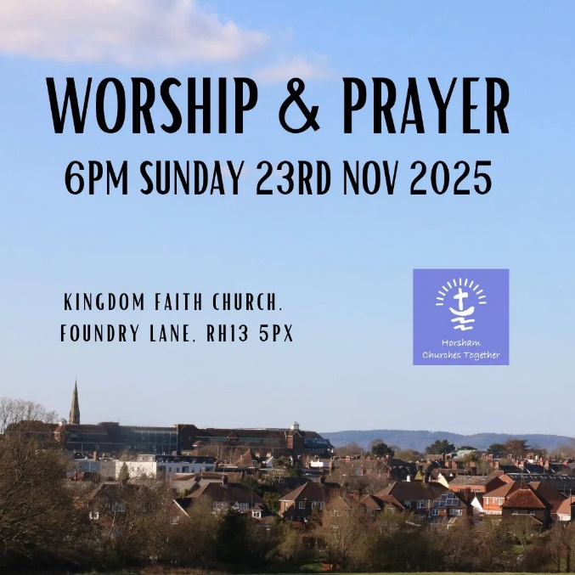
As we continue to pray for our town and villages, everyone is invited to the next HCT Worship & Prayer evening

- When: 6pm on Sunday, November 23rd, 2025
- Where: Kingdom Faith Church in Horsham (RH13 5PX)
Can’t make it? Then, then join the Horsham Virtual Prayer Room Facebook Group and check out the Prayer of the Week on the Horsham Churches Together homepage.

Please use these resources to share this event with your church: Social Media Graphic (1:1), Presentation Slide (16:9), Presentation Slide (4:3), Poster to print (A4), Flyers to print (A6), ZIP of all files

Back to Contents

- Saturday 29th November 2025, Horsham Fairtrade Christmas Market and the Sussex Green Hub
A note for your diary - Horsham Fairtrade Christmas Market, Saturday 29th November 2025 10am - 4pm @ St John’s RC Church Hall (next to the Lynd Cross). There will be a fabulous array of Fairtrade Christmas foods, gifts and treats – Cocoa Loco chocolate, Love that Stuff clothes and jewellery, Nika Deluxe toiletries, Siwok wooden crafts. baskets from Ghana, Amazonian crafts, foods, gifts, clothing, Christmas cards and Advent calendars from Fairtrade retailers. Luxurious toiletries, stunning textiles, delicious chocolate and much more! Sales of all of these items help workers in the developing world to improve their lives. Download a poster for this event

The Fairtrade mark means that farmers and producers get a fair price for their products and that they have safe and healthy working conditions. Plus, they receive a Fair-Trade premium to spend in their local community. This Fair-Trade premium was often spent on medical facilities or a school. Now it is mostly spent on countering the effects of climate change. Visit the Fairtrade stall to find out more about Fairtrade’s Climate Change Campaign.

Additionally, visit the Sussex Green Hub at the United Reformed Church, opposite St John's Church Hall, 10am - 2.30pm on the same day, to learn more about local environmental initiatives.
Back to Contents

- Saturday 29th November, Wreath Making Workshop
Hosted by Life Community Church – Storrington, a Wreath Making Workshop (in aid of Life Support Charity)
- When: Saturday 29th November, 10am - 1pm
- Venue: West Chiltington Village Hall, Mill Rd, West Chiltington, RH20 2PZ

Create your own beautiful, personalised festive wreath whilst also making a difference for those in need! Design your own stunning wreath to take home, the perfect way to begin the festive season.
All materials are provided, but feel free to bring your own decorations for a personal touch.

Enjoy festive nibbles, good company, and a cheerful atmosphere.
Tickets: £35 per person

All proceeds will go towards the work of Life Support, a charity working with communities in developing countries to help vulnerable children and adults move out of poverty by providing essentials such as food, education, shelter, training, and employment. (www.lifesupportcharity.org)

To book your place visit the Life Community Church, Storrington’s website.
Back to Contents

- Saturday 29th November: Billingshurst Choral Society will be playing @ St Mary’s Church Horsham
Billingshurst Choral Society (BCS), along with members of Hastings Philharmonic Orchestra (HPO) will be performing at St. Mary's Parish Church, Horsham on Saturday 29th of November at 7.30pm. The first half of the concert will feature two wonderful pieces by Mozart: Divertimento in D Major, played by HPO and Solemn Vespers sung by the Choral Society. The second half of the programme will be the beautiful Fauré Requiem. For further information and to buy your tickets, please visit the BCS website: billingshurstchoralsociety.org.uk

Back to Contents

- Sunday 30 November 2025 – Kingdom Faith Vision Event
Kingdom Faith Church are hosting a ‘Safe Families and Home for Good Vision Event’. Everyone has a part to play: fostering, adoption, supported lodgings, volunteering, advocacy, giving or praying. What part could you play?

Safe Families and Home for Good strive for a society where no family feels alone, and every child has a home where they can flourish. They believe the Church is central to this change.

This Vision Event will be taking place:
- Sunday, 30th November 2025
- 12.45pm | Kingdom Faith Church, Foundry Lane Horsham, RH13 5PX

For more information and to book your place visit Eventbrite
Alternatively contact Billy-Jo on 07586 688054 or email billyjo.oleary@homeforgood.org.uk

Back to Contents

DECEMBER:
- Friday 5th December: ‘The Magic of Christmas’
Horsham Matters present “The Magic of Christmas”. Sponsored by Howden, this festive evening will take place at 7:30pm on Friday 5th December at St Mary’s Church, Horsham, featuring incredible performances from the contemporary gospel choir Singergy, the Rock Choir, and local legend Jodie Munday.

Tickets priced £15 per person are available from the Horsham Matters website, or the Love it Again shop in West Street, Horsham. All profits will go to support the work of Horsham Matters.

Enjoy a magical evening filled with festive music, mulled wine, mince pies, and a raffle with amazing prizes!

Back to Contents

- Saturday 6th December: Carols in the Carfax 2025
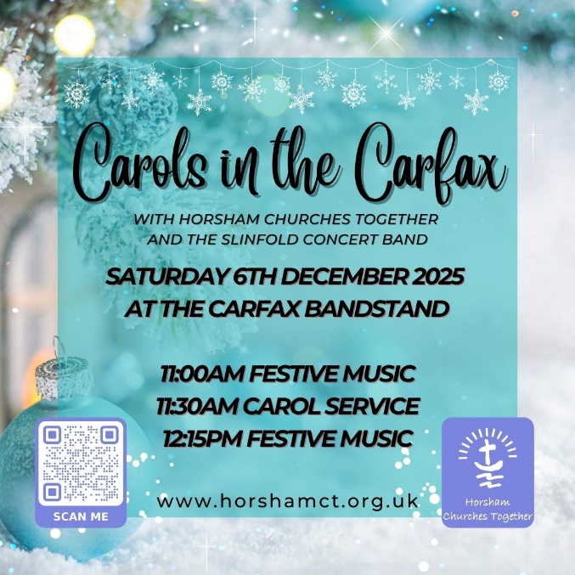
Join us in Horsham Town centre for Horsham Churches Together Carols in the Carfax, with the Slinfold Concert Band. Starting with festive music 11am, then a carol service from 11:30am to 12:15pm with singing, Bible readings, and a gospel talk, followed by more festive music until 1pm.
When: 11pm – 1pm on 6th December 2025
Where: Carfax Bandstand, Carfax, Horsham, RH12 1FD
Directions: Google Maps or Apple Maps
Parking: Town centre car parks or Horsham Park & Ride
Cycling: Cycle racks are located in Medwin Way, next to the Swan Centre.
Please use these graphics to promote the event in your church:
- Social Media Graphic (1:1)
- Presentation Slide (16:9)
- Presentation Slide (4:3)
- Poster to print (A4)
- Flyers to print (A6)
Download all files in the Media Pack ZIP

Back to Contents

- Saturday 13th December: Trafalgar Community Choir ‘A Christmas Pudding Time'
Trafalgar Community Choir presents "A Christmas Pudding Time". A festive, fun-filled evening of songs, music, and delicious puds! Saturday 13th December at 7pm at Trafalgar Road Baptist Church. Tickets £10 (children free). All proceeds go to support St Catherine's Hospice.

For tickets, please get in touch with Steve Davies on 07887 59052 / steveldavies37@tiscali.co.uk

Download a flyer or a handout for this event

Back to Contents

JANUARY 2026:
- Saturday 10th of January 2026: The Way of the Spirit - Word & Spirit - LIFE!
'The Way of the Spirit' are passionate about God's Word and want to see Christians from all backgrounds engaging with the Bible daily and growing in their relationship with God.

You are invited to an open morning where you can see the resources 'The Way of the Spirit' offers, meet the Horsham team and find out more about the vision for Bible reading groups.

They are looking forward to meeting you on Saturday 10th of January 2026, 10 am to 12pm, Kingdom Faith Church, Foundry Lane, Horsham, arrive at any time. Refreshments will be provided. All are welcome.
For more information about The Way of the Spirit – Horsham, visit their website

Back to Contents

- Save The Date

- New Year - 2026
    - HCT Week of Prayer for Christian Unity: 18th – 25th January 2026
    - HCT Good Friday Service in the Carfax: Friday 3rd April, 11:15am

ii) 2026 HCT Forum Meeting Dates (Time:7PM for 7.30PM start – Venues to be advised)
    - Tuesday 10th February
    - Wednesday 13th May
    - Thursday 16th July, Forum, including AGM
    - Thursday 8th October
Back to Contents


- Prayer of the week
- Peace in the Rush

The Christmas season is beginning to stir across our district. Shop windows are filling with light, cafés are planning festive menus, and the sound of Christmas songs will soon drift through our streets and villages .

For many, it’s a joyful time. For others, the pace and pressure are already building. So, this week, we’re praying for peace in the rush – for calm hearts, patient words, and those small moments of kindness that remind us we belong to one another.

As shops and cafés grow busier across Horsham and the surrounding villages, we pray for all those who work in retail and hospitality, warehousing and delivery.

Lord,
bring peace in the pressure,
when the pace feels relentless,
steady anxious hearts and tired minds.

Lord, bring joy in the serving,
and may every act of service,
and every warm greeting,
carry something of your love.

And bring rest to us all!
Lord, help us to slow down,
to notice you at work in the everyday,
and to make space for your presence.
Amen.

Back to Contents

- Employment Opportunities
- Horsham Matters are hiring! – Part-Time Communications & Marketing Officer
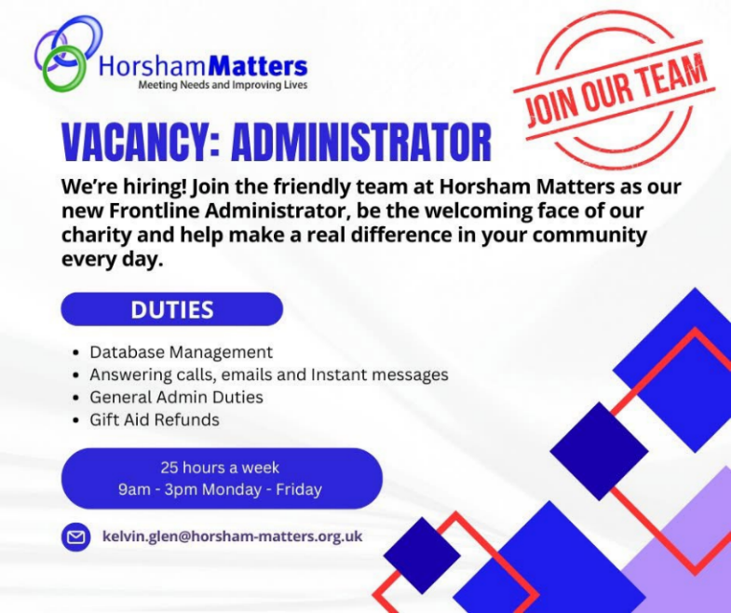
Horsham Matters is a local charity dedicated to alleviating hardship and meeting the needs of people in our community. Their vision is to ensure that no one in our community faces hardship alone.

Are you a creative storyteller with a passion for making a difference in your community? Horsham Matters is looking for a talented Communications & Marketing Officer to help share the Horsham Matters’ story, celebrate their impact, and grow awareness of their vital community services and charity shop.

What you'll do:
- Manage and create inspiring content across social media (Facebook, Instagram, LinkedIn, X, TikTok)
- Keep their website fresh with weekly updates, news, and community stories
- Design eye-catching visuals and campaigns using Canva or similar tools
- Collaborate with staff and volunteers to bring their mission to life through authentic storytelling
- Ensure communications reflect Horsham Matters' values and brand voice

Required:
- Proven experience in communications, marketing, or digital content creation (charity experience a plus! but not essential)
- Confident using social media and design tools
- Strong writing and organisational skills
- A collaborative, proactive mindset and passion for community impact
- Part-time: 20 hours per week
- Location: Horsham Matters, Redkiln Close (In person)
- Apply by: Sunday 16th November 2025

If you're ready to use your creativity to make a real difference, they would love to hear from you!
👉 For an informal discussion please email rob.blaker@horsham-matters.org.uk
👉 To make an application please email your CV and a covering letter to Rob.blaker@horsham-matters.org.uk
Closing Date 16th November 2025

Back to Contents

- Frontline Administrator required at Horsham Matters
Join the friendly team at Horsham Matters as their new ‘Frontline Administrator’ - be the welcoming face of the charity and help make a real difference in your community every day.

Duties:
- Database Management
- Answering calls, emails and Instant messages
- General Admin Duties
- Gift Aid Refunds
- 25 hours a week: 9am – 3pm Monday to Friday

💚 Find out more email: kelvin.glen@horsham-matters.org.uk
Back to Contents

- Vacancy at Horsham Matters: Retail Assistant – 20 hours per week
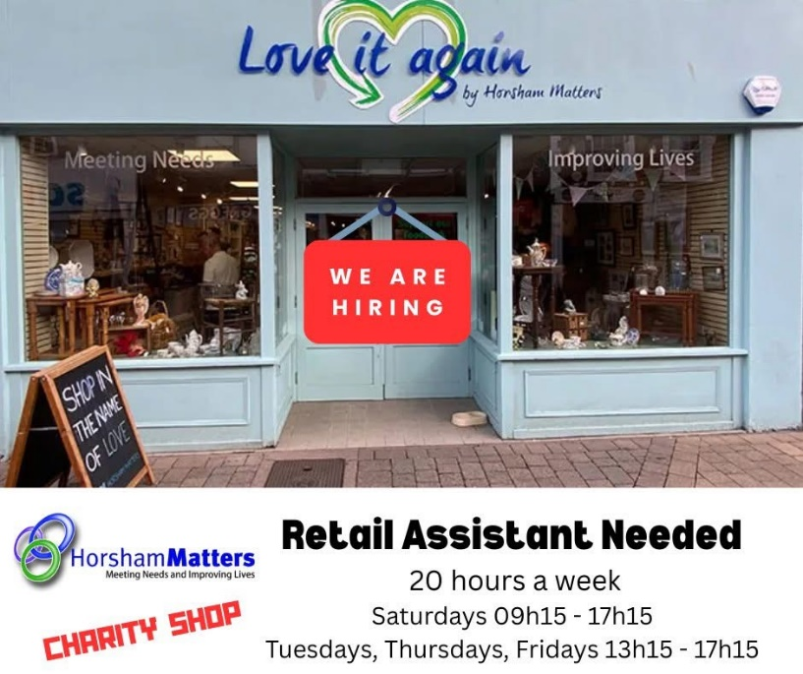
Are you passionate about people, community, and making a difference? Horsham Matters is looking for a Retail Assistant to join their friendly team at their bespoke charity shop on West Street, Horsham.

🗓 Start Date: 2nd January 2025
📍 Location: West Street, Horsham
⏰ Hours: 20 hours per week

They are looking for someone who will bring sparkle, positivity, and great energy to their team, someone who can make their donors and shoppers feel welcome and valued every day. By working in the charity shop, you'll be helping to support the local community and the clients who turn to Horsham Matters in times of hardship.

💌 To apply: Send your CV to:
info@horsham-matters.org.uk
✨ “Join us in making a difference, one customer at a time!” ✨
Back to Contents

- Volunteering Opportunities
- Governor vacancies at All Saints CE Primary School
All Saints are looking for committed individuals to join their Governing Board and uphold the Christian vision and ethos of our school. Being a governor is a truly rewarding experience and whist it is a big responsibility it is also a wonderful opportunity to make an invaluable contribution to the education of young people. No formal qualifications or experience is required as full training will be provided.

For more information, please read this letter from the Chair of Governors or email: clerk@allsaintshorsham.school.
Back to Contents

- Horsham Matters need Volunteers
The need in our community continues to grow—and so does the need for compassionate volunteers.
Horsham Matters require further volunteers. They have a variety of roles to suit your interests and schedule:
- Supporting families at the Horsham District Foodbank
- Sorting and preparing donations in their Warehouse
- Serving and restocking at their Charity Shop
- Welcoming guests at the Connecting Café
- Assisting with Fundraising to keep their services running

Just a few hours a week can transform lives. Training and support are provided.
Can you join as a Volunteer at Horsham Matters?
Please email amalia.lovett@horsham-matters.org.uk to find our more and for an application.

Back to Contents

- Volunteers needed at Dalesdown
Could you spare a few hours either weekly or occasionally to help out at Dalesdown? Dalesdown is a Christian residential conference and activity centre at Dial Post. The Dalesdown team are looking to expand its volunteers. For further details download their information document. If you would be interested in volunteering in any way, please contact Zoe – events@dalesdown.org.uk
Back to Contents

- YMCA Horsham Y Centre are looking for volunteer Chaplains
The YMCA Horsham Y centre is looking for bright and cheerful volunteer chaplains to join their team. They are looking for someone who is kind and compassionate. The role consists of cooking a meal, eating and talking with the residents. They require a commitment of volunteering fortnightly for at least one year. Their sessions are held in Horsham Y centre on Thursdays 5.30-8pm. For more details and how to apply visit the website Volunteer Chaplains - YMCA DownsLink Group or contact Dani Fray on 07912271164 danielle.fray@ymcadlg.org.
Back to Contents

- Volunteer Trustees required at The Oasis
Could you contribute to your community by volunteering as a Trustee for The Oasis using your past and/or current work experiences and skills? For further details download a poster.

If this is of interest, please contact Dawn Spouge – info@theoasis.org.uk or 01403 272 723 or look at their website to understand more of what they do www.theoasis.org.uk.
Back to Contents

Please Note
Whilst we’ve carefully chosen these events and notices because we hope they will be useful to you and your church family, we are not directly responsible for the content from external groups and organisations.
Horsham Churches Together
Back to Contents

