A notice to churches
Please send your notices for sharing with Horsham Churches Together to admin@horshamct.org.uk by Wednesday 3pm, as notices are usually published from approximately 4pm each Wednesday. Any notices received after this publication time will be held for the following week.
Please read the HCT privacy notice for details on how we collect, store and process your personal information under UK GDPR. The HCT administrator Anna Pisani can be contacted during office hours on Wednesdays.

Check out the new Horsham Churches Together website, including the Community Pages section,

Horsham Churches Together Notices
10th December 2025

Contents

- News
- Christmas What’s on Guide
- HCT Notices, Christmas & New Year
- The Sound of Christmas fills Horsham's Carfax
- Horsham Eco Churches Ten Tips for a Greener Christmas 2025
- The Oasis Festive Newsletter
- Advent and Christmas resources 2025
- Week of Prayer for Christian Unity 2026
- Christmas Appeals
- HRSG Christmas Appeal 2025
- Salvation Army, Christmas Appeal
- Horsham Matters’ Christmas Appeal update
- Events
- “What’s on at Christmas Guide”
- Saturday 10th of January 2026: The Way of the Spirit - Word & Spirit - LIFE!
- Save The Date
- Advanced notice of HCT Events and Forums
- Prayer of the week
- Praying for Connections this Christmas
- Employment Opportunities
- Frontline Administrator required at Horsham Matters
- Vacancy at Horsham Matters: Retail Assistant – 20 hours per week

- Volunteering Opportunities
- Horsham Matters need Volunteers
- Volunteers needed at Dalesdown
- YMCA Horsham Y Centre are looking for volunteer Chaplains
- Volunteer Trustees required at The Oasis
- News

- Christmas What’s on Guide
We’ve collated this year’s Christmas services and festive events run by our churches and charities into our online “What’s On at Christmas” guide, full of community carolling, Christingles, festive fayres, concerts, Christmas services and much, much more. Check it out and help us share the Good News this Christmas.

To share in your churches, please download these graphics for your newsletters and projectors: PowerPoint (16:9), / PowerPoint (4:3), / and Social Media (Square).

If we’re missing anything, please email the details to hello@horshamct.org.uk.
Back to Contents

- HCT Notices, Christmas & New Year
The HCT Notices will be taking a break over Christmas and New Year, with the last edition of 2025 scheduled for publication on Wednesday 17th December. The HCT Notices will resume in the New Year on Wednesday 7th January 2026.

Back to Contents

- The Sound of Christmas fills Horsham's Carfax
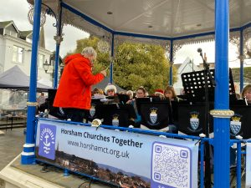
The sound of Christmas filled the market in Horsham town centre on Saturday 6th December, as people gathered for Horsham Churches Together’s Carols in the Carfax. The Slinfold Concert Band opened the morning with festive music before leading everyone in classic carols, including “O Come All Ye Faithful” and “Joy to the World”.

Between the carol singing, the Christmas story was read by local representatives from the Salvation Army, the YMCA and Christians Against Poverty. Hearing these familiar words from people who walk alongside some of the most vulnerable in our community reminds us that the Good News of Jesus’ birth still brings hope into our community today.

Rev Tim Stilwell brought smiles all round as he captured the joy of a child playing hide-and-seek, and the pure delight of being found. It was a beautiful image of a God who loves to be found. The band closed the event with a mix of festive favourites that carried the sound of joy throughout the Christmas market once more.

There’s still more to come from churches in Horsham District, with carol singing in the community, Christmas services, charity concerts, Christingles, crib services and much more. You’re welcome to join us as we celebrate Christmas. Visit https://horshamct.org.uk/christmas/ for the full “What’s On at Christmas” guide and discover an event taking place in a church near you.

Back to Contents

- Horsham Eco Churches Ten Tips for a Greener Christmas 2025
Read and download the updated Horsham Eco Churches ‘Ten Tips for a Greener Christmas 2025’ - Ideas from Horsham Eco Churches for a greener, more sustainable Christmas.

Back to Contents
- The Oasis Festive Newsletter
Find out about ‘The Oasis Crisis Pregnancy Centre’ latest news and what they have been up to since their summer newsletter with their Festive Newsletter 2025. From all those at Oasis, they “wish you all a very blessed happy Christmas and New Year”.

Back to Contents

- Advent and Christmas resources 2025

Advent is a four-week Christian season of reflection and anticipation leading up to Christmas, focusing on the advent of Jesus Christ and his promised return. More than a simple countdown, it's a time for practices like prayer and reading scriptures to cultivate hopeful waiting, joyful peace-making, and love, with Advent 2025 beginning on Sunday November 30th to Wednesday 24th December. Read more on The Meaning and Significance of Advent .
Churches Together in Britain and Ireland (CTBI) and Churches Together in England (CTE) are compiling Resources for Advent and Christmas 2025, including those from a wide range of churches and Christian organisations.

Back to Contents

- Week of Prayer for Christian Unity 2026
The Week of Prayer for Christian Unity runs from 18th to 25th January 2026, with prayer meetings throughout the week and a united service at St Mary's at 6pm on Saturday 25th January. Check out the Week of Prayer for Christian Unity page for details.

Download an overview graphic for your projectors and newsletters. We will create a detailed version once all events have been confirmed.
Back to Contents

- Christmas Appeals

- HRSG Christmas Appeal 2025
A message from Horsham Refugee Support Group (HRSG):-
“Christmas is now approaching and we are planning Christmas parties and gifts for all the refugees and asylum seekers that we support. This is approximately 70 families in our locality. We are very grateful to Lifespring Church and Billingshurst Family Church, who are making gift boxes for our asylum-seeking families.

We would also like to give our refugee families a gift from the community and you may wish to contribute. The donations will be used to buy vouchers so that families can choose how they spend their gift – on a treat for their children, towards their next food shop or on clothes and shoes. We will give all of our local refugee families the same gift at our party in December. Please ensure your donations are received by Friday 19 December, otherwise we may not be able to include them.

How to donate: It's quick and easy to donate on Justgiving, and you can also add Gift Aid:
https://www.justgiving.com/campaign/hrsg-christmas-campaign-2025

Alternatively, you can donate directly to our bank account:
- Sort Code: 60-11-17
- Account Number: 27033597
- Please mark your donation with the reference "Christmas".
If you wish to Gift Aid your donation, please contact our Treasurer, Nick O'Riordan, at nick@horshamrefugeesupportgroup.co.uk

Many thanks for your generosity.
Wishing you all a merry Christmas and a happy New Year,
Joanna and the HRSG Team
Horsham Refugee Support Group”
Back to Contents

- Salvation Army, Christmas Appeal: ‘Be a star and donate a gift’
Christmas is fast approaching, and preparations are beginning again at The Salvation Army in Horsham, to offer help to families who are experiencing difficulties, with referrals made through Schools and Social Services. Support from other churches and the general public, will always be gratefully welcomed.
Could you help to make Christmas special for those who may have little or nothing under the tree on Christmas morning?

Salvation Army are collecting donations of new unwrapped toys, toiletry sets, and money toward the purchase of gift cards for older teenagers and supermarket vouchers for Christmas Dinner, from now until the 12th December. Gifts donated after this time are still very gratefully received but may be kept until next year if distribution is complete or shared with another Salvation Army church for their toy appeal.

If you are able to help, download a flyer which contains further details or donate on their JustGiving page.

Back to Contents

- Horsham Matters’ Christmas Appeal update
The date for the Horsham Matters’ Christmas appeal has now past, but please do continue with your regular food bank donations to enable Horsham Matters to support those in need in the coming year.

Back to Contents

- Events

Click on the following image to be taken to our ‘What’s on at Christmas Guide”

With the Season of Advent just around the corner, we’ve collated this year’s Christmas services and festive events run by our churches and charities into our online “What’s On at Christmas” guide, full of community carolling, Christingles, festive fayres, concerts, Christmas services and much, much more. Check it out and help us share the Good News this Christmas. If we’re missing anything, please email the details to hello@horshamct.org.uk.
Back to Contents

JANUARY 2026:
- Saturday 10th of January 2026: The Way of the Spirit - Word & Spirit - LIFE!
'The Way of the Spirit' are passionate about God's Word and want to see Christians from all backgrounds engaging with the Bible daily and growing in their relationship with God.

You are invited to an open morning where you can see the resources 'The Way of the Spirit' offers, meet the Horsham team and find out more about the vision for Bible reading groups.

They are looking forward to meeting you on Saturday 10th of January 2026, 10 am to 12pm, Kingdom Faith Church, Foundry Lane, Horsham, arrive at any time. Refreshments will be provided. All are welcome.
For more information about The Way of the Spirit – Horsham, visit their website

Back to Contents

- Save The Date

- New Year - 2026
    - HCT Week of Prayer for Christian Unity: 18th – 25th January 2026 (with the United Service at St Mary's, Horsham, on Sunday 25th January @ 6pm)
    - HCT Good Friday Service in the Carfax: Friday 3rd April, 11:15am

ii) 2026 HCT Forum Meeting Dates (Time:7PM for 7.30PM start – Venues to be advised)
    - Tuesday 10th February
    - Wednesday 13th May
    - Thursday 16th July, Forum, including AGM
    - Thursday 8th October
Back to Contents

- Prayer of the week
- Praying for Connections this Christmas

As Advent continues, you’ll have noticed our neighbourhoods sparkling with the light of Christmas.
Photo from 2025 Christingle Service at Brighton Road BC

And throughout the villages and towns, our churches have already been welcoming our community into festive fairs, singing carols in the streets, and creating Christingles with great joy. So, we pause and give thanks for all that has already happened, and for the friendships and connections that are being made in our community.

And with so much more still to come, we also pray for the days ahead. For everyone who will connect with a church, join a service, or take part in a festive event, we pray the light of Christ will meet them in a real and life changing way.

Take a moment to pause with us today, to give thanks and to pray.

Let’s hold Horsham in God’s light together this Christmas.

Back to Contents

- Employment Opportunities

- Frontline Administrator required at Horsham Matters
Join the friendly team at Horsham Matters as their new ‘Frontline Administrator’ - be the welcoming face of the charity and help make a real difference in your community every day.

Duties:
- Database Management
- Answering calls, emails and Instant messages
- General Admin Duties
- Gift Aid Refunds
- 25 hours a week: 9am – 3pm Monday to Friday
💚 Find out more email: kelvin.glen@horsham-matters.org.uk
Back to Contents

- Vacancy at Horsham Matters: Retail Assistant – 20 hours per week
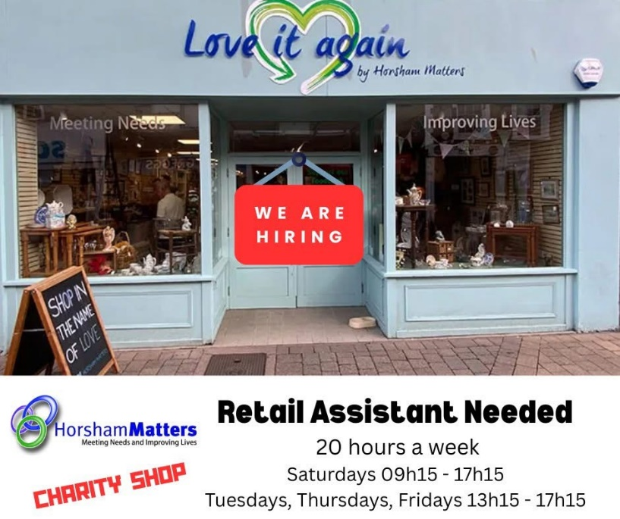
Are you passionate about people, community, and making a difference? Horsham Matters is looking for a Retail Assistant to join their friendly team at their bespoke charity shop on West Street, Horsham.

🗓 Start Date: 2nd January 2026
📍 Location: West Street, Horsham
⏰ Hours: 20 hours per week

They are looking for someone who will bring sparkle, positivity, and great energy to their team, someone who can make their donors and shoppers feel welcome and valued every day. By working in the charity shop, you'll be helping to support the local community and the clients who turn to Horsham Matters in times of hardship.

💌 To apply: Send your CV to:
info@horsham-matters.org.uk
✨ “Join us in making a difference, one customer at a time!” ✨
Back to Contents

- Volunteering Opportunities

- Horsham Matters need Volunteers
The need in our community continues to grow—and so does the need for compassionate volunteers.
Horsham Matters require further volunteers. They have a variety of roles to suit your interests and schedule:
- Supporting families at the Horsham District Foodbank
- Sorting and preparing donations in their Warehouse
- Serving and restocking at their Charity Shop
- Welcoming guests at the Connecting Café
- Assisting with Fundraising to keep their services running

Just a few hours a week can transform lives. Training and support are provided.
Can you join as a Volunteer at Horsham Matters?
Please email info@horsham-matters.org.uk to find out more and for an application.
Back to Contents

- Volunteers needed at Dalesdown
Could you spare a few hours either weekly or occasionally to help out at Dalesdown? Dalesdown is a Christian residential conference and activity centre at Dial Post. The Dalesdown team are looking to expand its volunteers. For further details download their information document. If you would be interested in volunteering in any way, please contact Zoe – events@dalesdown.org.uk
Back to Contents

- YMCA Horsham Y Centre are looking for volunteer Chaplains
The YMCA Horsham Y centre is looking for bright and cheerful volunteer chaplains to join their team. They are looking for someone who is kind and compassionate. The role consists of cooking a meal, eating and talking with the residents. They require a commitment of volunteering fortnightly for at least one year. Their sessions are held in Horsham Y centre on Thursdays 5.30-8pm. For more details and how to apply visit the website Volunteer Chaplains - YMCA DownsLink Group or contact Dani Fray on 07912271164 danielle.fray@ymcadlg.org.
Back to Contents

- Volunteer Trustees required at The Oasis
Could you contribute to your community by volunteering as a Trustee for The Oasis using your past and/or current work experiences and skills? For further details download a poster.

If this is of interest, please contact Dawn Spouge – info@theoasis.org.uk or 01403 272 723 or look at their website to understand more of what they do www.theoasis.org.uk.
Back to Contents

Please Note
Whilst we’ve carefully chosen these events and notices because we hope they will be useful to you and your church family, we are not directly responsible for the content from external groups and organisations.
Horsham Churches Together
Back to Contents

