A notice to churches
Please send your notices for sharing with Horsham Churches Together to admin@horshamct.org.uk by Wednesday 12pm, as notices are usually published from approximately 4pm each Wednesday. Any notices received after this publication time will be held for the following week.

Please read the HCT privacy notice for details on how we collect, store and process your personal information under UK GDPR. The HCT administrator Anna Pisani can be contacted during office hours on Wednesdays.
Check out the new Horsham Churches Together website, including the Community Pages section,

Horsham Churches Together Notices
8th April 2026
- News
- Good Friday in the Carfax 2026
- New style HCT Notices – coming soon
- Spring Update from Horsham Debt Advice Service
- Horsham Eco Churches April News
- ‘Born in Song’ - Competition to write a poem or song
- New website for Horsham Matters
- 20 Years of Horsham Matters
- The Elephant in the Room
- Open the Book
- Events
- SEND Café @ St Mark’s Church Holbrook
- Tues 14th April, ‘Who Do We Turn to When Things Don't Work Out How We Hoped They Might?’
- Wednesday 15th April, CAP Money Coaching Course
- Saturday 18th of April, Billingshurst Choral Society’s Haydn: The Creation
- Sunday 19th April 2026 – HCT Prayer & Worship Evening @ Kingdom Faith Church
- Tuesday 21st April, ‘The People’s Emergency Briefing’: Horsham Green Film Festival
- "Called to Influence" Course
- Friday 24th April, Quiz & Cheeseboard Evening at Holy Trinity Church
- Saturday 25th April, Horsham Matters' Quiz Night
- Saturday 9th May, Youth Praise Night @ Trafalgar Road Baptist Church
- Saturday 9th May, HDAS Quiz night, at St Mark’s Church
- 11th – 20th May, Methodism in Horsham Exhibition
- Monday 8th June 2026, ‘Left to Their Own Devices?’ with Katharine Hill
- Sunday 14th June 2026, HCT Prayer & Praise in the Park
- Employment Opportunities
- Dalesdown is looking to recruit casual housekeepers for the 2026 summer season
- Volunteering Opportunities
- Could you be there for a child in care?
- Save The Date
- Advanced notice of HCT Events and Forums
- Prayer Focus
- Easter

- News

- Good Friday in the Carfax 2026
Christians from across Horsham and the surrounding villages gathered in the Carfax on Good Friday to remember the death of Jesus Christ and to celebrate his resurrection from the grave. Rt Revd Ruth Bushyager, Bishop of Horsham, shared the memorable story of her husband writing to thank the manufacturer of the cycle helmet that saved his life, inspiring those gathered to give thanks to Jesus, as the one who saves our lives.

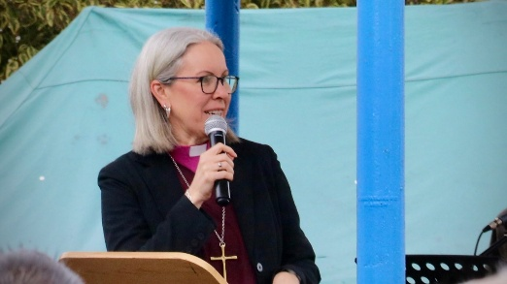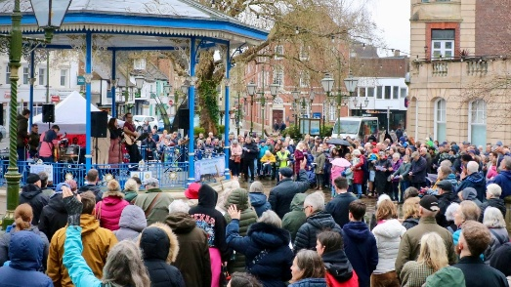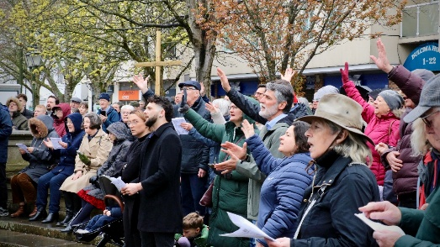

Musicians from Christian Life Centre led the worship, blending reflective music on Jesus' sacrifice with uplifting songs of praise for His victory over sin and death. Chris Aldridge from St Mark's Holbrook captivated hearts with his reading from the Passion narrative in the Gospel of Mark, before Pastor Joyce Nduka from Living Faith Assembly lifted our hearts in prayer for the town and led the congregation in prayer.

- New style HCT Notices – coming soon
We will soon be launching our new style HCT Notices. Same great content, with a brand-new look. The new design will make it easier than ever to stay connected with what’s happening in churches across Horsham District each week. Your news and events also will be directly available on the HCT website too, making it easier to share your notices with wider audience.

Please email us your news and events to share to admin@horshamct.org.uk by 12 noon on Wednesdays. This deadline is moving earlier in the day to help us manage workflow throughout the day.

Behind the scenes, we will be switching email service providers. You don’t need to do anything, but we have updated our Privacy Notice to reflect the change.

Back to Contents

- Spring Update from Horsham Debt Advice Service
Read the Spring update from Horsham Debt Advice Service, which includes the nationwide news that Christians Against Poverty (CAP) and Community Money Advice (CMA) are uniting as a group to form the UK’s largest specialist community-based debt advice charity.
Back to Contents

- Horsham Eco Churches April News
Download and read the latest newsletter from Horsham Eco Churches which includes news about: Climate Adaptation & Resilience, Horsham Green Film Festival, Eco Church Evensong, Environment Day and much more!
Back to Contents

- ‘Born in Song’ - Competition to write a poem or song
As part of the 250th anniversary of Methodism in Horsham, Cornerstone London Road are inviting entries of spiritual/reflective poems or a Christian worship song, for their ‘Born in Song’ competition.

- Could you write a spiritual/reflective poem or a Christian worship song?
- Would you like to perform your work or see and hear it performed by a reader or choir at their live ‘Born in Song’ concert on 19 September 2026?

Enter their free ‘Born in Song’ prize competition. For more information, including downloading an Entry Pack, Competition Rules, Entry Form, Promotional Poster, Handouts and PPT slides, visit Cornerstone Methodist Church, London Road’s website Closing date: Midnight, Sunday 28 June 2026

Back to Contents

- New website for Horsham Matters
Over the last 6 months, Horsham Matters have been working with britweb on a brand-new website - and it’s NOW LIVE! Check out the new website at www.horsham-matters.org.uk, where you will find all the information you need on their services, how to get help and how to get involved in supporting your local community.

Back to Contents

- 20 Years of Horsham Matters
Twenty years ago, this year, Horsham Matters was registered as a charity to be a social action arm of Horsham Churches Together, to support individuals and families facing hardship within Horsham District. As part of their 20th anniversary celebrations, Horsham Matters would love to hear your stories. Can you share a memory from those early days? Do you have any photographs you could share? How has the work of Horsham Matters made a difference to you and your community over the years? Please email your stories or photos to Kelvin Glen, Horsham Matters CEO - kelvin.glen@horsham-matters.org.uk .
Back to Contents
- The Elephant in the Room
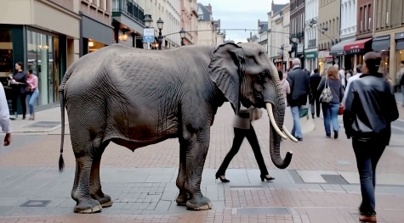
We need to face the Elephant in the Room; homelessness has become such a familiar sight that, too often, people are walking past without seeing the human reality. Turning Tides, we are asking our community to pause, reflect and confront this uncomfortable truth through their Elephant in the Room campaign, because when something so serious becomes something we simply ‘walk past’, we all lose a little part of our humanity. Continue reading on the Turning Tides website.

Back to Contents

- Open the Book
Open the Book is an exciting storytelling project delivered by church volunteers into their local primary schools. It enables the children to hear Bible Stories in their school assemblies but also to be involved in the storytelling itself. The stories and assemblies are scripted and Bible Society provide numerous resources and ideas to enable you to present the assemblies in an engaging and entertaining way for the children watching. Church volunteer storytellers will receive free training from their Regional Trainer who will also be on hand to support and encourage them as they develop the team and their storytelling in their local schools.

For more information, please visit the Open the Book website, or email Steff Shepherd, Regional Trainer and Development Officer for Open the Book, Bible Society in the Southeast, who would love to tell you more about Open the Book as something you could use in the schools you are already visiting or as a creative way of visiting new schools in your area - steff.shepherd@biblesociety.org.uk

Back to Contents

- Events

APRIL 2026:
- SEND Café @ St Mark’s Church Holbrook
St Mark’s Church, Holbrook, have started a drop in café for parents of SEND children to chat, share, and connect with people who understand your journey - Download a Flyer. These will be Mondays 10am-12noon: on 13th April, 11th May. Children are welcome to come along too.

If Mondays don't work for everyone but you are interested in other SEND Family events and support please get in touch with St Mark’s Church by emailing familyhub@stmarksholbrook.org.uk
Back to Contents

- Tues 14th April, ‘Who Do We Turn to When Things Don't Work Out How We Hoped They Might?’
Where do we go to find HOPE IN TIMES OF ADVERSITY? - A study day, at Dalesdown, Dial Post, near Horsham on Tuesday, on 14th April from 10 am to 4 pm, exploring how knowing that God is with us provides us with strength, courage and perseverance during challenging situations. Led by evangelist and author, Alison Fenning. The day will incorporate a mixture of teaching, worship, reflection and fellowship time, with an opportunity for prayer. For more information download a poster

Tickets are available to book on Eventbrite -
Hope in Adversity Tickets, Tuesday, Apr 14, 2026 | Eventbrite

Additionally, details of all other Dalesdown events and links for booking can be found on their website - https://www.dalesdown.org.uk/upcoming-events

Back to Contents

- Wednesday 15th April, CAP Money Coaching Course
The next CAP (Christians Against Poverty) Money Course, is commencing Wednesday 15th April, a four-week free course designed to empower people with the knowledge, skills, tools and confidence to better manage their finances. The sessions will be interactive with videos, activities, introduction to the online tool and CAP money management system. They are suitable for anyone who wants to get on top of their budget.

- Horsham Daytime Course at: The Drill Hall, Denne Road, Horsham, RH12 1JF -
10 - 12noon on Wednesday mornings on the 15th, 22nd, 29th April & 6th May 2026
Book in link:
https://moneycoaching.capuk.org/join-course/a93285f2-5be6-447d-9b2b-dedef7f77c1b

There's a one-minute video about the course to help people get a feel of the material they use - just go to the website to watch capuk.org/trymoneycoaching

If you or someone you know are interested in attending, book in using the links above or via the website. If you'd like more information please contact 07477660531 or moneycoaching@wearelifespring.church (please leave a name, contact number and an email address).

Remember also that CAP (Christians Against Poverty) Debt Help is available providing face to face home visits and support for those in unmanageable debt. For more information http://capuk.org/debthelp and to self-refer for debt help contact 0800 328 0006

Back to Contents

- Saturday 18th of April, Billingshurst Choral Society’s Haydn: The Creation
Haydn: The Creation, will be performed by Billingshurst Choral Society (BCS) accompanied by Hastings Philharmonic Orchestra at St. Mary's Parish Church, Horsham, RH12 1HE on Saturday 18th of April. The performance will begin at 7.30pm and light refreshments will be available during the interval. Adult tickets £20.00, under 18s and students are free, but you must register at the online box office. The conductor will be the renowned Marcio da Silva, and you will be assured of a wonderful evening. For further information and to buy tickets, please visit the BCS website: www.billingshurstchoralsociety.org.uk
Download a flyer for this event.
Back to Contents

- Sunday 19th April 2026 – HCT Prayer & Worship Evening @ Kingdom Faith Church
Join us for an evening of worship & prayer, as we unite together from across the churches to worship Jesus, pray for our local communities and listen to God speak into our lives.

  - When: 6pm - 7:30pm, Sunday 19th April 2026
  - Where: Kingdom Faith Church, Foundry Lane, Horsham, RH13 5PX
  - Directions: Google Maps or Apple Maps
  - Parking: Onsite and local streets
  - Cycling: Cycle racks are by the main entrance.

Media Pack:
Please use our media pack to help you spread the word and invite others within your church:
- Noticesheets - Event Graphic
- Projectors - Widescreen / Standard
- Social Media - Facebook Post / Instagram Post / Story / Square
- Posters - A3 Landscape / A4 Landscape
- Handouts - A6 Postcards
- Download all the images with our Media Pack ZIP file.
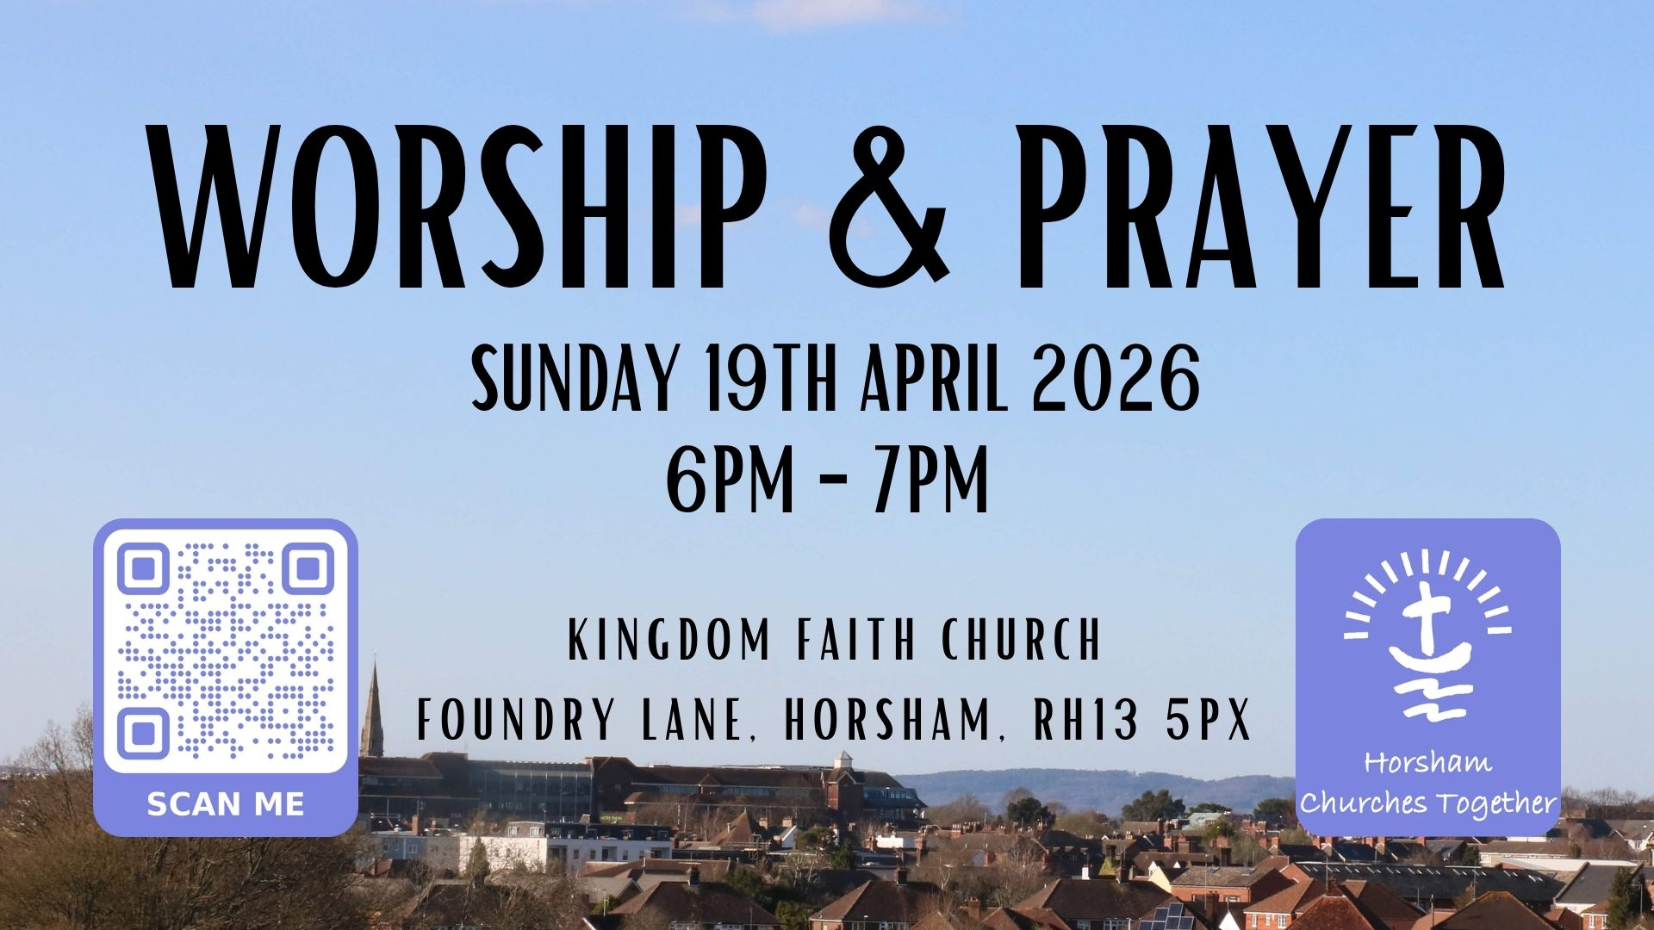

Back to Contents

- Tuesday 21st April, ‘The People’s Emergency Briefing’: Horsham Green Film Festival
Free series of screening of insightful films – just turn up! The next film will be on Tuesday 21st April, called ‘The People’s Emergency Briefing’. Doors open at 7pm, film starts at 7.30pm at Trafalgar Baptist Church, Horsham, RH12 2QL Bring Your Own snacks and soft drinks.

Back to Contents

- "Called to Influence" Course
Begins on the 22nd April over seven consecutive Wednesday evenings, 19.00-21.00 via Zoom. To learn more about the course and signup if interested at www.calledtoinfluence.com/grouptraining.
Karen Kircher karen@leadingleaders.co.uk (A colleague of Revd Michael Hogg at Brighton Road Baptist Church, Horsham)

Have you ever considered that God's missional plan for you sits in your everyday life? Only a small percentage of Christians are called to full time church ministry, but we are all instructed to, "Go and make disciples of all nations, baptising them in the name of the Father and of the Son and of the Holy Spirit." (Matthew 28:19) By radically changing the way you think about work and learning how to partner with God as you go about your daily activities you can experience greater job satisfaction as you bring Kingdom influence and transformation to those around you. Wherever God has positioned you this is where you are called to influence.
Back to Contents

- Friday 24th April, Quiz & Cheeseboard Evening at Holy Trinity Church
An evening of Fun, Brainpower and Delicious Snacks! Happening on Friday 24th April 7:00 - 10:30pm
at Holy Trinity Church Horsham. Teams of 6 please. Tickets are £15 which includes a cheeseboard for 6 for supper; there is a cheese alternative. For more information download a poster and to book your tickets visit Holy Trinity’s Church Suite.

Back to Contents

- Saturday 25th April, Horsham Matters' Quiz Night
Think you've got what it takes to be crowned quiz champions? Join a fun-filled Quiz Night to raise funds for Horsham Matters! Bring your friends, test your knowledge, and help support families across the Horsham District while you're at it.
- Max 6 people per team
- £10 per person (includes nibbles!)
- Bragging rights up for grabs!
- Download a poster

When: Saturday 25th April, Doors open at 7:00pm, Quiz starts at 7:30pm
Where: The Scout Hut, Church Street, Rudgwick, Horsham RH12 3HJ

Book by email to fundraising@horsham-matters.org.uk
Back to Contents

MAY 2026:
- Saturday 9th May, Youth Praise Night @ Trafalgar Road Baptist Church
‘Youth Praise Nights West Sussex’ – a night of worship, community and encounter for 14-24-year olds, will be taking place at Trafalgar Road Baptist Church, Horsham on 9th May, 6:45pm to 9:15pm. Download a poster for this event.

Back to Contents

- Saturday 9th May, HDAS Quiz night, at St Mark’s Church
Horsham Debt Advice Service (HDAS) will be having a fundraising Quiz night at St Mark’s Church, Horsham on Saturday 9th May (free parking in car park), 6.30 pm to 9.30 pm

£5 per person - maximum of 6 per team. Bring your own drinks and snacks (tea and coffee provided). There will also be a Raffle.

All proceeds to Horsham Debt Advice Service - helping those who have fallen into debt to see the light at the end of the tunnel. Please email advisor@hdas.co.uk to book a table so they can cater for tables and drinks to be prepared.
Back to Contents

- 11th – 20th May, Methodism in Horsham Exhibition
Methodism in Horsham and surrounding exhibition villages over the last 250 years. 11th to 20th May 2026 at Horsham Library.
Back to Contents

JUNE 2026:
- Monday 8th June 2026, ‘Left to Their Own Devices?’ with Katharine Hill
St Mark’s Holbrook are hosting a Care for the Family event ‘Left to Their Own Devices? – Parenting in a Digital Age’ with Katharine Hill. This event is not just for parents but for anyone involved with children and young people. It will equip parents and carers with practical skills and knowledge to stay ahead of the curve and help children navigate the online world safely and to their advantage. This event is free of charge and will be taking place at St Mark's Church, Horsham, Monday, 8th June from 7:30 pm to 9:30 pm. Early booking is encouraged. For more information and to book download a flyer and visit Eventbrite.

Back to Contents

- Sunday 14th June 2026, HCT Prayer & Praise in the Park
Join us for an afternoon of prayer and praise in Horsham Park on Sunday 14th June 2026, with live worship music and prayers for our local churches and communities. Service start at 5pm, with gates open for picnics from 4pm.
When: 4pm for picnics, 5pm for service, Sunday 14th June 2026
Where: Human Nature Garden, Horsham Park (///switch.making.held)
General Parking: Pavilions Car Park, Hurst Road, Horsham, RH12 2DF
Accessible Parking: Jubilee Car Park, Madeira Avenue, Horsham, RH12 1AB
Please download these resources to help you spread the word and invite others:
  - Noticesheets – Event Graphic
  - Projectors – Widescreen / Standard
  - Social Media – Portrait Post / Square Post / Story
  - Posters – A3 Landscape / A4 Landscape
  - Postcards – 4 x A6 postcards on a A4 sheet
  - Download all the images with our Media Pack ZIP file
Back to Contents

- Employment Opportunities

- Dalesdown is looking to recruit casual housekeepers for the 2026 summer season
For more information and to apply visit Dalesdown’s website.

Back to Contents

- Volunteering Opportunities

- Could you be there for a child in care?
The Independent Visitor team is looking for volunteers to become ‘Independent Visitors’ - friendly faces who spend time with children aged 8 to 17 who are looked after by the county council and won't be returning to live with their family.

It's all about fun, friendship and doing activities the young person enjoys and building a positive connection (expenses are covered to a set amount). Want to learn more? Visit the website: Independent Visitor Scheme - West Sussex County Council

The team is also running two online information sessions in April – click the links below to book.
- Monday 27th April 7pm - WSCC Independent Visitor Scheme - Information Session | Meeting-Join | Microsoft Teams
- Tuesday 28th April 12.30pm - https://events.teams.microsoft.com/event/3043d4b9-ce54-49ef-8698-8f6e9888f4ae@257fdadc-5c0c-4dfa-977e-9386dfd72d22

Back to Contents

- Save The Date

- 2026 HCT Events:
    - HCT Prayer & Worship Evening @ Kingdom Faith, Sunday 19th April 2026
    - HCT Prayer & Praise in Human Nature Garden, Horsham Park, Sunday 14th June. Service start at 5pm, with gates open for picnics from 4pm.

- 2026 HCT Forum Meeting Dates (Time:7PM for 7.30PM start):
    - Wednesday 13th May at United Reformed Church, Horsham, RH12 2RG
    - Thursday 9th July, Forum, including AGM, at Cornerstone Methodist Church, London Road, Horsham RH12 1AN
    - Thursday 8th October at Brighton Road Baptist Church, Horsham RH13 5BD

Back to Contents

- Prayer Focus
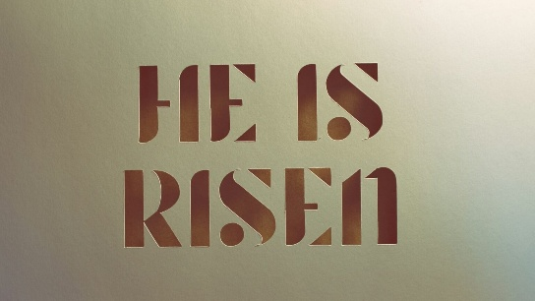
- The Living Hope

With the joy of Easter in our hearts, let's pray that we'd live the reality of the resurrection every day, not merely as "spectators of the miracle" but "participants in the mission," carrying the light of Easter into our daily work and routines. May our weary bodies run with the eagerness of Mary to tell others about the resurrection of Jesus. May our downcast hearts burn with passion like the disciples on the road to Emmaus. And may our doubting eyes be opened like Thomas' as he encountered our Risen Saviour.
Back to Contents

Please Note
Whilst we’ve carefully chosen these events and notices because we hope they will be useful to you and your church family, we are not directly responsible for the content from external groups and organisations.
Horsham Churches Together.
Back to Contents

